Module Five Packet Tracer Activity

William Pascoe
CYB-210: Computer Networking
Jamilah Telon
October 4, 2025

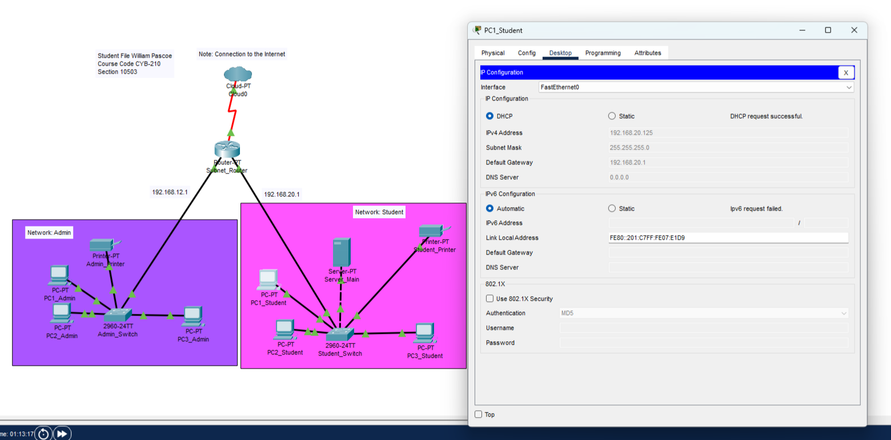
IP Configuration
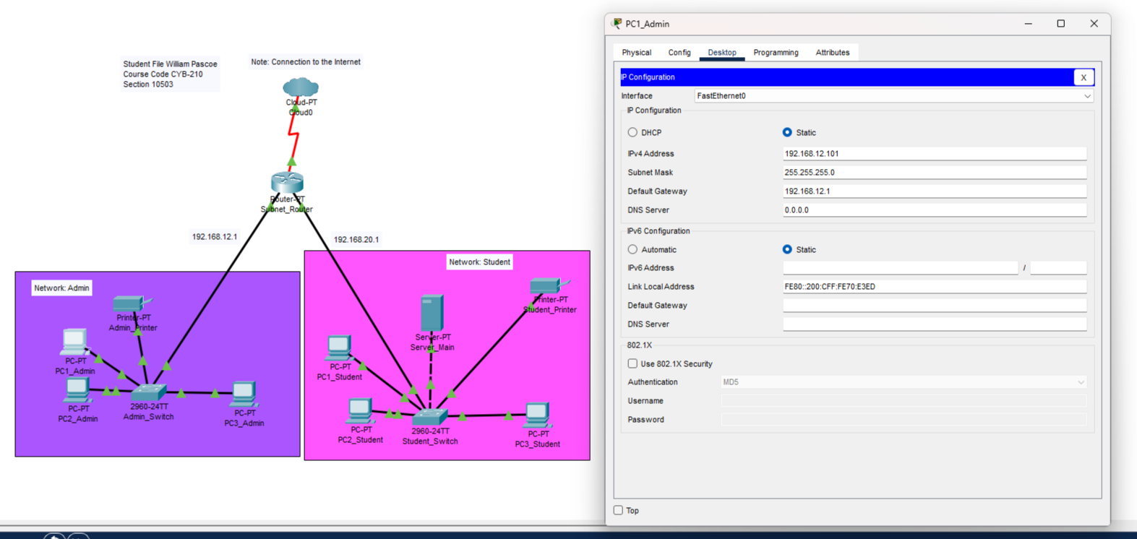
For the admin computer I went into the config tab and changed the default Gateway in the Settings Tab. Then I went to the FastEthernet tab and changed the static IP address. For the Student computers I changed the IP address to DHCP.
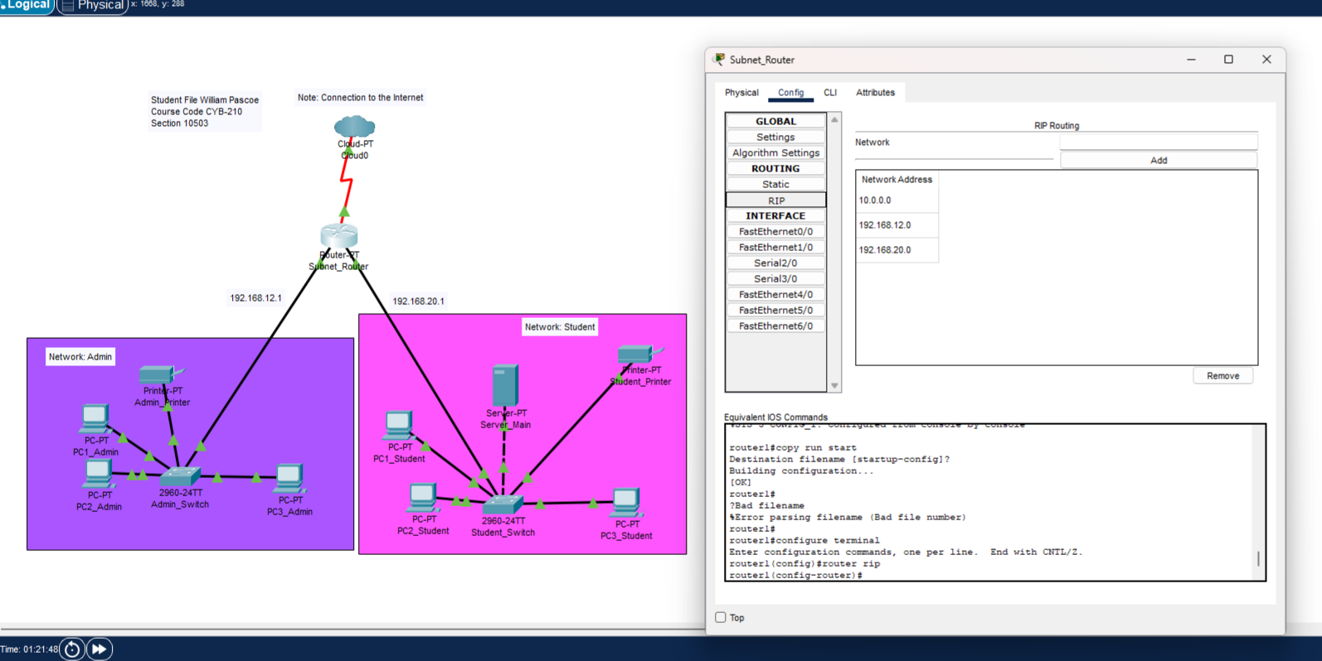
RIP Configuration
For the RIP Configuration I went into the RIP tab of the router and added in the new networks then I removed the old ones.

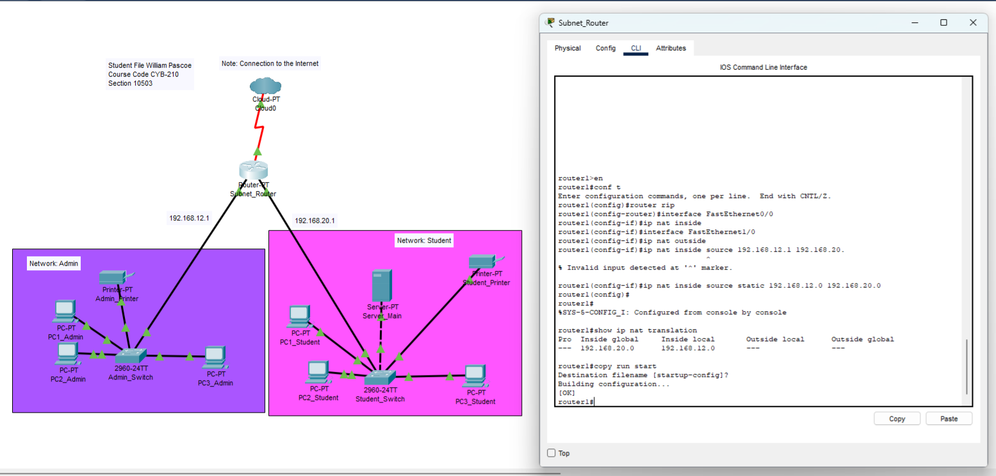
NAT Configuration
For Nat I set the inside and outside nat to proper IP Addresses.

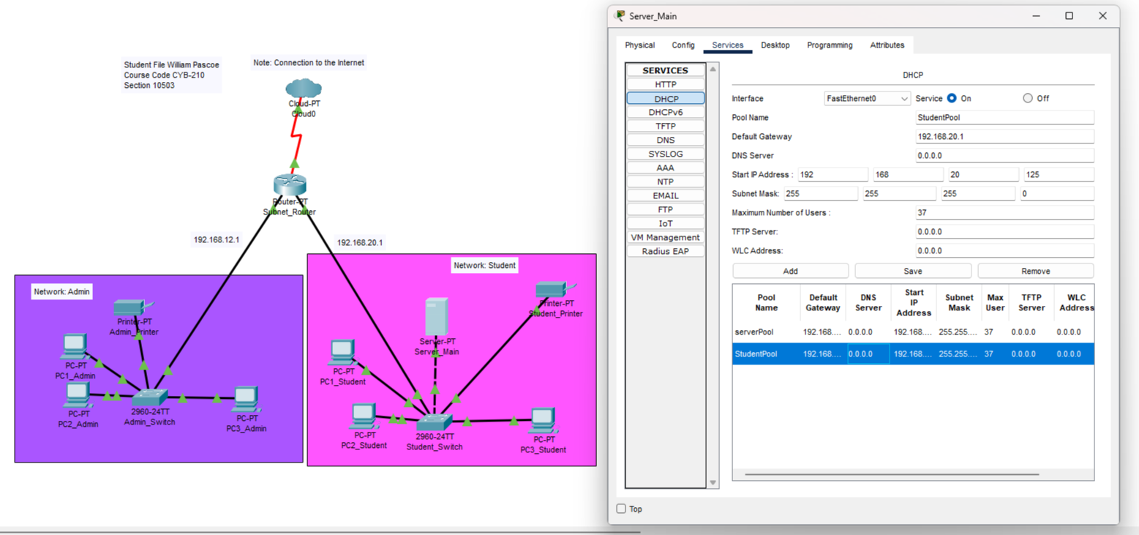
DHCP Services

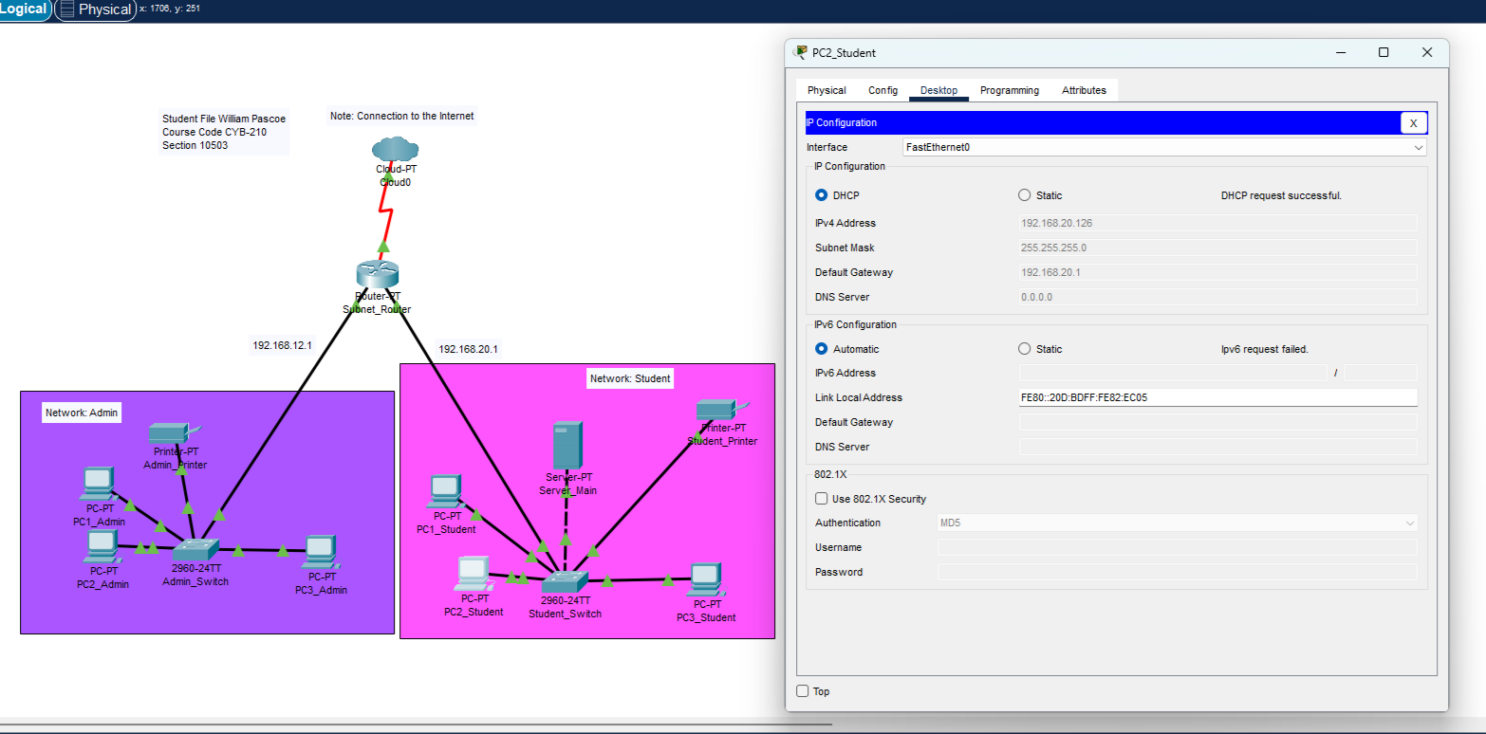
Device showing DHCP Information

For DHCP services I went into the server main and under the DHCP tab I setup a new Student pool and added the appropriate information

DNS Services
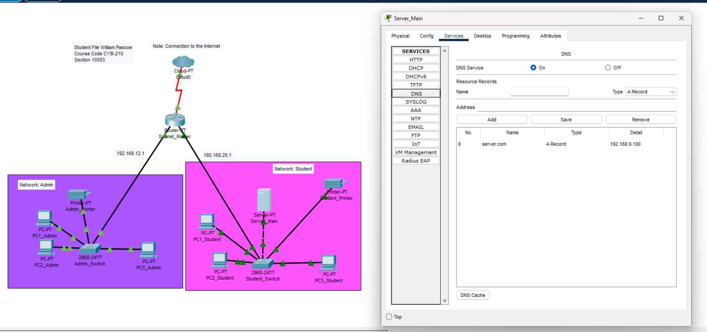
For DNS Services I went into the server main and under the DNS tab I configured the DNS service.

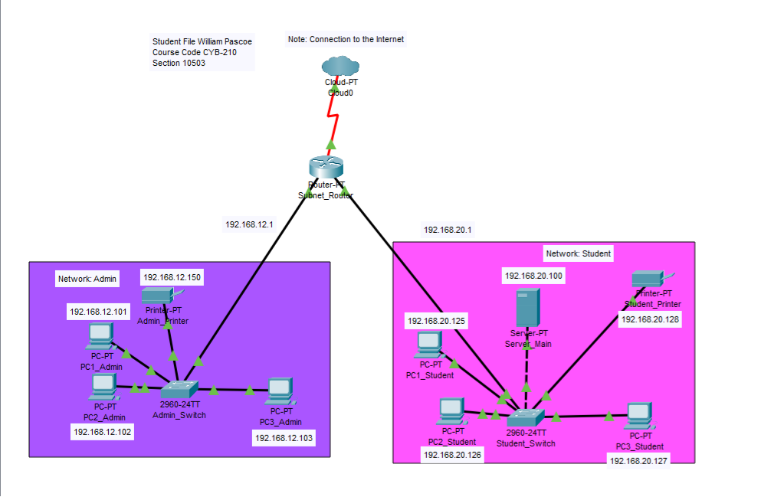
Completed Network Topology

